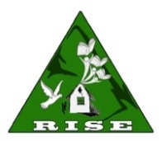
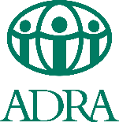
CALL FOR TENDERS FOR Transportation Services (Extension)

ADRA Myanmar and KTWG intend to award a service contract for Transportation Service in Myanmar with financial assistance from the European Union and MEC. The tender dossier which includes the (1) service contract notice, (2) Instructions to Tenderers and (3) Tender Information Form is available at www.adramyanmar.org/tenders or the bid documents may collected (in soft copy) from the ADRA Myanmar office.

The bid documents written in English, must be submitted in hard copy not later than 25th February 2020 (Tuesday) 4:00 (4:00 pm) Myanmar time to the following address:

The Logistics Officer
ADRA Myanmar
Room (A, 3-2), E-Condo, 4th Floor,
North Bazaar Road,
Dagon Township, Yangon,
Myanmar.
Phone: (+95) 01- 240900/01380419

The bid must be submitted by sealed envelope and include:
- The ADRA Myanmar address
- The name and address of the bidder
- Publication reference: “TLMS-II/2019/ADRA Myanmar-KTWG”

